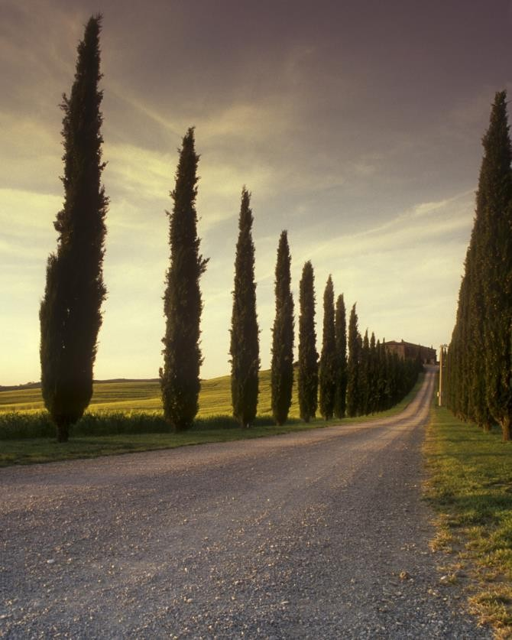

|  |  |
| --- | --- |
| EXEL PRACTICE IN PIVOT TABLE  Assignment | **Submission Date: 17/05/2024**  **Submitted by: Anonna Saha Roy Bristi Submitted to: Md. Mahabub-E-Noor**  **Course Titel: Computer Fundamentals & Office Appplication**  **Batch: 67th** |

**Solution No. 1:** Step 1:First click on insert and click on Pivot Tabile.

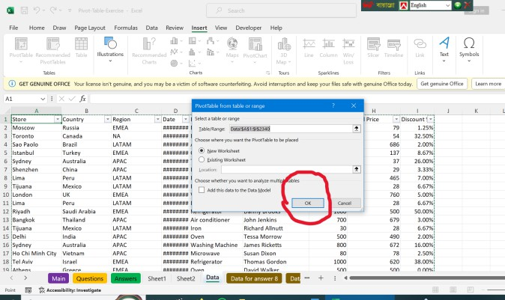

Step 2: Click OK

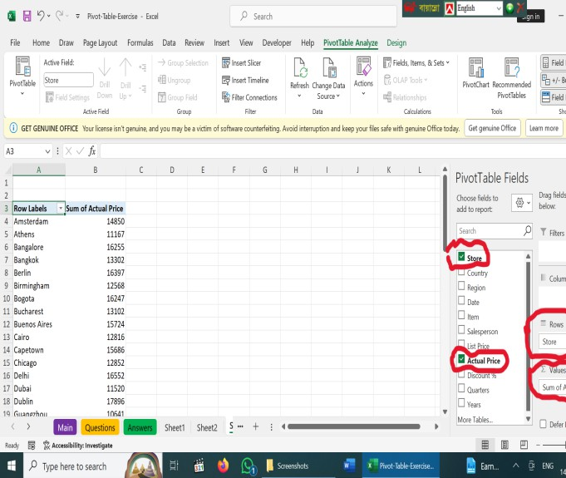

Step 3: Then a dialog box appear like this.From here select Store in Row and Actual price in Value.

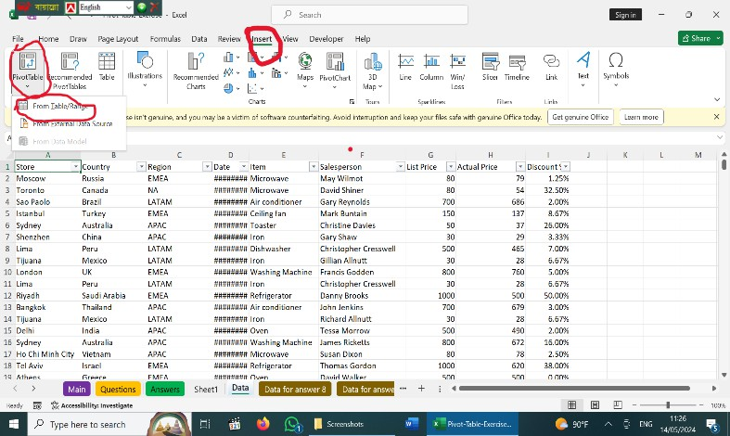Click on its Table/Range.

|  |  |
| --- | --- |
| **Row Labels** | **Sum of Actual Price** |
| Amsterdam | 14850 |
| Athens | 11167 |
| Bangalore | 16255 |
| Bangkok | 13302 |
| Berlin | 16397 |
| Birmingham | 12568 |
| Bogota | 16247 |
| Bucharest | 13102 |
| Buenos Aires | 15724 |
| Cairo | 12816 |
| Capetown | 15686 |
| Chicago | 12852 |
| Delhi | 16552 |
| Dubai | 11520 |
| Dublin | 17896 |
| Guangzhou | 10641 |
| Ho Chi Minh City | 10698 |
| Houston | 3671 |
| Istanbul | 12263 |
| Jerusalem | 10932 |
| Kansas City | 15163 |
| Kuala Lumpur | 12700 |
| Lima | 11257 |
| London | 16987 |
| Los Angeles | 15424 |
| Madria | 17477 |
| Mexico City | 11917 |
| Moscow | 21083 |
| New York | 14197 |
| Osaka | 14835 |
| Paris | 16374 |
| Prague | 16686 |
| Riyadh | 12205 |
| Rochester | 3095 |
| Rome | 11910 |
| San Fransisco | 15800 |
| Santiago | 13040 |
| Sao Paolo | 13051 |
| Seattle | 9990 |
| Seoul | 15677 |
| Shanghai | 15643 |
| Shenzhen | 9957 |
| Sydney | 14886 |

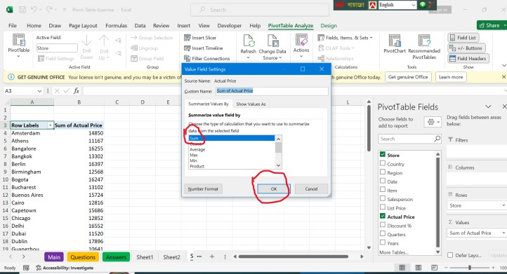

Step 4:

|  |  |
| --- | --- |
| Tel Aviv | 15277 |
| Tijuana | 17253 |
| Tokyo | 15884 |
| Toronto | 11938 |
| Vancouver | 4653 |
| Vienna | 13672 |
| Warsaw | 14846 |
| **Grand Total** | **678016** |

Solution no 2:

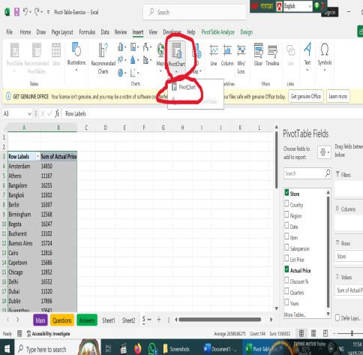

Step 5:

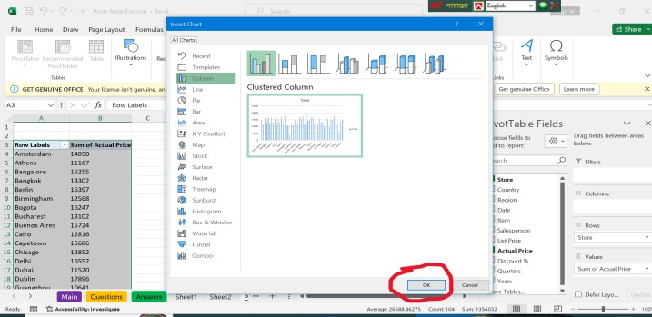

Step 6:

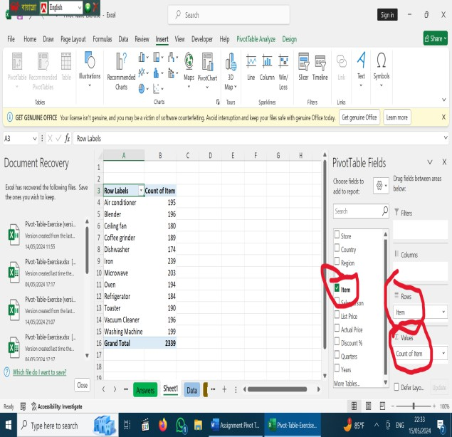

Step 1:

|  |  |
| --- | --- |
| **Row Labels** | **Count of Item** |
| Air conditioner | 195 |
| Blender | 196 |
| Ceiling fan | 180 |
| Coffee grinder | 189 |
| Dishwasher | 174 |
| Iron | 239 |
| Microwave | 203 |
| Oven | 194 |
| Refrigerator | 184 |
| Toaster | 190 |
| Vacuum Cleaner | 196 |
| Washing  Machine | 199 |
| **Grand Total** | **2339** |

Solution no. 3:

|  |  |  |  |  |  |
| --- | --- | --- | --- | --- | --- |
| **Count of Item** | **Column Labels** |  |  |  |  |
| **Row Labels** | **APAC** | **EMEA** | **LATAM** | **NA** | **Grand**  **Total** |
| Air conditioner | 54 | 82 | 26 | 33 | 195 |
| Blender | 43 | 88 | 34 | 31 | 196 |
| Ceiling fan | 40 | 82 | 24 | 34 | 180 |
| Coffee grinder | 53 | 77 | 27 | 32 | 189 |
| Dishwasher | 37 | 90 | 27 | 20 | 174 |
| Iron | 60 | 100 | 35 | 44 | 239 |
| Microwave | 52 | 90 | 30 | 31 | 203 |
| Oven | 48 | 78 | 31 | 37 | 194 |
| Refrigerator | 49 | 84 | 26 | 25 | 184 |
| Toaster | 45 | 72 | 30 | 43 | 190 |
| Vacuum Cleaner | 41 | 92 | 32 | 31 | 196 |
| Washing  Machine | 48 | 89 | 30 | 32 | 199 |
| **Grand Total** | **570** | **1024** | **352** | **393** | **2339** |

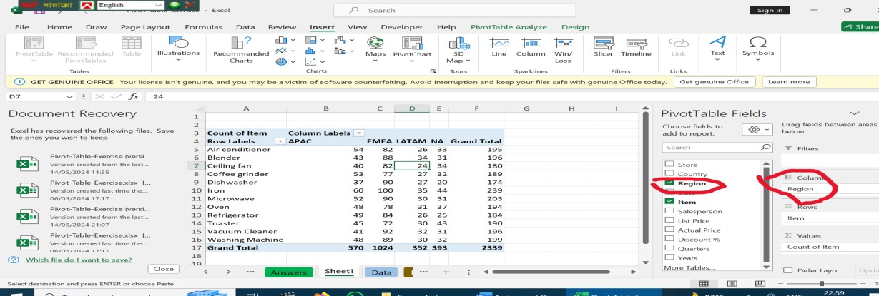

Step 1:

Solution 4:

|  |  |  |  |  |
| --- | --- | --- | --- | --- |
| **Count of Item** | **Column Labels** |  |  |  |
| **Row Labels** | **APAC** | **EMEA** | **LATAM** | **Grand**  **Total** |
| Microwave | 52 | 90 | 30 | 172 |
| Oven | 48 | 78 | 31 | 157 |
| Refrigerator | 49 | 84 | 26 | 159 |
| **Grand Total** | **149** | **252** | **87** | **488** |

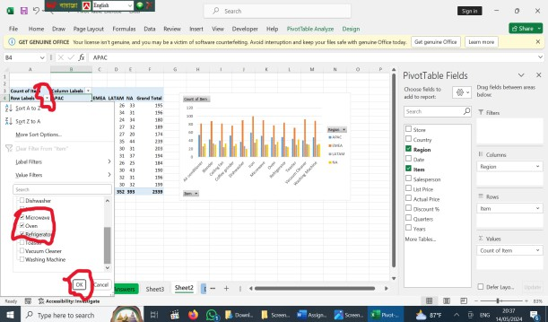

Step 1:

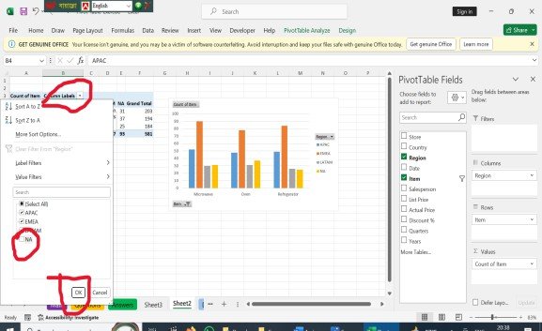

Step 2:

Solution no. 5:

|  |  |  |  |
| --- | --- | --- | --- |
| **Row Labels** | **Average of Discount %** | **Count of Item** | **Sum of Actual Price** |
| Edward Khan | 14.29% | 7 | 3785 |
| David Stewart | 10.95% | 7 | 2717 |
| Nick Denny | 14.72% | 7 | 1941 |
| Maureen Haymes | 5.67% | 3 | 1607 |
| Andrew Waddell | 8.00% | 3 | 1218 |
| Pauline Pluck | 19.67% | 3 | 1169 |
| Terence Mirza | 7.46% | 4 | 1055 |
| Stephen Nolan | 11.01% | 6 | 883 |
| Rachel Blane | 8.78% | 4 | 803 |
| Christopher Martin | 12.63% | 5 | 758 |
| Christopher Lloyd | 13.67% | 3 | 673 |
| Alison Hallows | 3.75% | 1 | 77 |
| **Grand Total** | **11.67%** | **53** | **16686** |

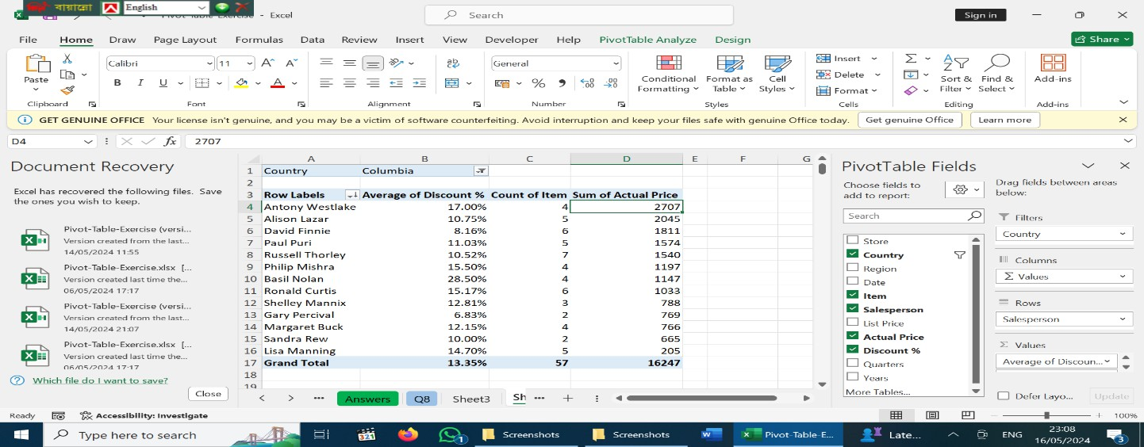

Solution no. 6:

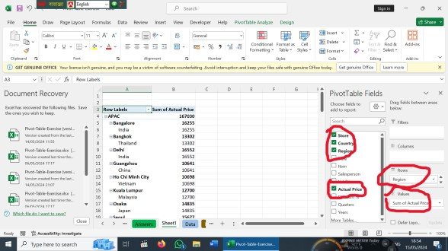

Step 1:

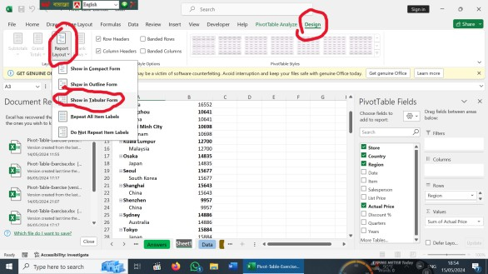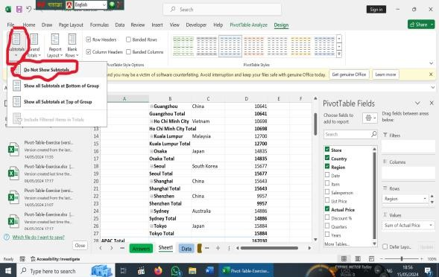

Step 3:

|  |  |  |  |  |
| --- | --- | --- | --- | --- |
| **Solution no. 7:** | | | | |
|  | **Region** | **Country** | **Store** | **Sum of Actual**  **Price** |
| **APAC** | |  |  | 167030 |
| **EMEA** | |  |  | 305714 |
| **LATAM** | |  |  | 98489 |
|  | **NA** |  |  | 106783 |
|  | **Grand**  **Total** |  |  | **678016** |
|  |  | | | |

|  |  |  |  |
| --- | --- | --- | --- |
| **Region** | **Country** | **Store** | **Sum of Actual**  **Price** |
| **APAC** | **Australia** | Sydney | 14886 |
| **APAC** | **China** | Guangzhou | 10641 |
| **APAC** | **China** | Shanghai | 15643 |
| **APAC** | **China** | Shenzhen | 9957 |
| **APAC** | **India** | Bangalore | 16255 |
| **APAC** | **India** | Delhi | 16552 |
| **APAC** | **Japan** | Osaka | 14835 |
| **APAC** | **Japan** | Tokyo | 15884 |
| **APAC** | **Malaysia** | Kuala  Lumpur | 12700 |
| **APAC** | **South Korea** | Seoul | 15677 |
| **APAC** | **Thailand** | Bangkok | 13302 |
| **APAC** | **Vietnam** | Ho Chi  Minh City | 10698 |
| **EMEA** | **Austria** | Vienna | 13672 |
| **EMEA** | **Czech**  **Republic** | Prague | 16686 |
| **EMEA** | **Egypt** | Cairo | 12816 |
| **EMEA** | **France** | Paris | 16374 |
| **EMEA** | **Germany** | Berlin | 16397 |
| **EMEA** | **Greece** | Athens | 11167 |
| **EMEA** | **Ireland** | Dublin | 17896 |
| **EMEA** | **Israel** | Jerusalem | 10932 |
| **EMEA** | **Israel** | Tel Aviv | 15277 |
| **EMEA** | **Italy** | Rome | 11910 |
| **EMEA** | **Netherlands** | Amsterdam | 14850 |
| **EMEA** | **Poland** | Warsaw | 14846 |
| **EMEA** | **Romania** | Bucharest | 13102 |
| **EMEA** | **Russia** | Moscow | 21083 |
| **EMEA** | **Saudi**  **Arabia** | Riyadh | 12205 |
| **EMEA** | **South Africa** | Capetown | 15686 |
| **EMEA** | **Spain** | Madria | 17477 |
| **EMEA** | **Turkey** | Istanbul | 12263 |
| **EMEA** | **UAE** | Dubai | 11520 |
| **EMEA** | **UK** | Birmingham | 12568 |
| **EMEA** | **UK** | London | 16987 |
| **LATAM** | **Argentina** | Buenos  Aires | 15724 |
| **LATAM** | **Brazil** | Sao Paolo | 13051 |
| **LATAM** | **Chile** | Santiago | 13040 |
| **LATAM** | **Mexico** | Mexico City | 11917 |
| **LATAM** | **Mexico** | Tijuana | 17253 |

|  |  |  |  |
| --- | --- | --- | --- |
| **LATAM** | **Peru** | Lima | 11257 |
| **LATAM** | **Columbia2** | Bogota | 16247 |
| **NA** | **Canada** | Toronto | 11938 |
| **NA** | **Canada** | Vancouver | 4653 |
| **NA** | **USA** | Chicago | 12852 |
| **NA** | **USA** | Houston | 3671 |
| **NA** | **USA** | Kansas City | 15163 |
| **NA** | **USA** | Los Angeles | 15424 |
| **NA** | **USA** | New York | 14197 |
| **NA** | **USA** | Rochester | 3095 |
| **NA** | **USA** | San  Fransisco | 15800 |
| **NA** | **USA** | Seattle | 9990 |
| **Grand**  **Total** |  |  | **678016** |

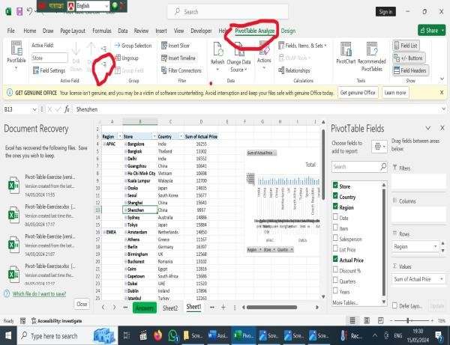

Step 1:

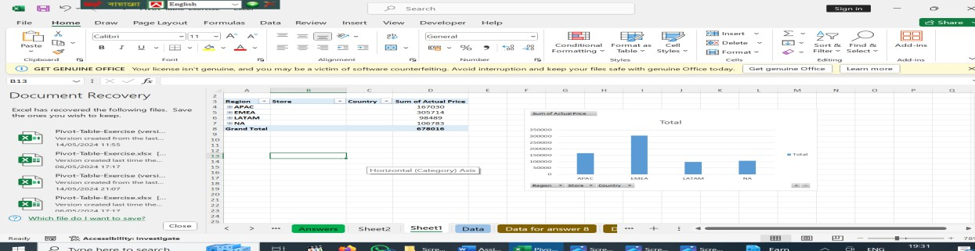

Step 2:

Solution no.8

|  |  |  |  |
| --- | --- | --- | --- |
| **Region** | **Country** | **Store** | **Sum of Actual Price** |
| **Americas** |  |  | 205272 |
| **APAC** |  |  | 167030 |
| **EMEA** |  |  | 305714 |
| **Grand Total** |  |  | **678016** |

Solution no.10

|  |  |
| --- | --- |
| Country | USA |
|  |  |
| **Row Labels** | **Sum of Actual Price** |
| Chicago | 12852 |
| Houston | 3671 |
| Kansas City | 15163 |
| Los Angeles | 15424 |

|  |  |
| --- | --- |
| New York | 14197 |
| Rochester | 3095 |
| San Fransisco | 15800 |
| Seattle | 9990 |
| **Grand Total** | **90192** |

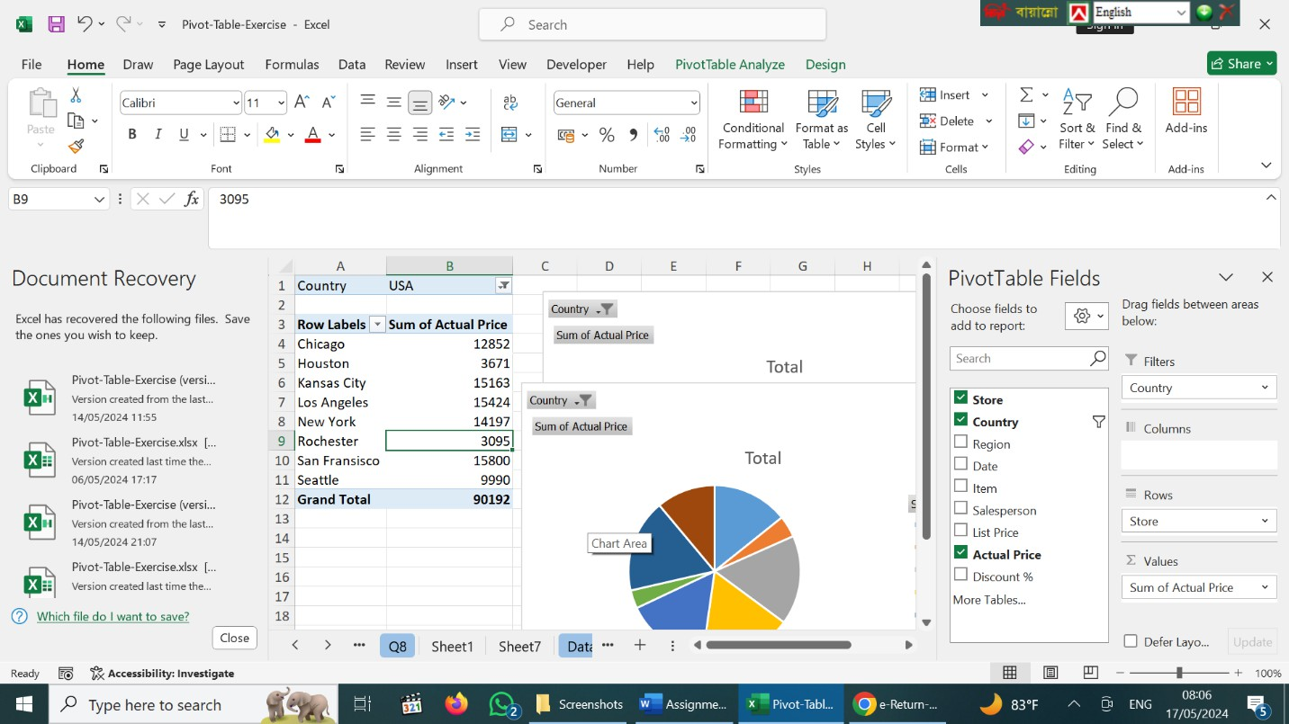

Solution no.11:

|  |  |
| --- | --- |
| **Row Labels** | **Sum of Actual Price** |
| Chicago | 158 |
| Kansas City | 219 |
| Los Angeles | 296 |
| New York | 349 |
| San Fransisco | 219 |
| Seattle | 332 |

|  |  |
| --- | --- |
| **Grand Total** | **1573** |

